This weeks featured game is [Dark Souls III](http://www.gamespot.com/dark-souls-iii)a game of valleys and peaks, down through dungeons and up over castle walls. It's a plummet into places we shouldn't be, an escape from places we don't belong.

But of course, we fight our way through the darkness, and find our way out. There are a few stumbles along the way, but in the end, Dark Souls III is well worth the riveting climb.

[Final Fantasy 15](http://www.gamespot.com/final-fantasy-xv)will launch on September 30, 2016 publisher Square Enix has announced. The date was revealed during the Uncovered: Final Fantasy XV event, which is being held in Los Angeles.

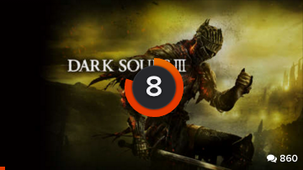

Great 8 user rating

In addition to the September release date, Square Enix revealed a lot of big news coming soon to Final Fantasy XV. Read it all here. This Highly-anticipated role-playing game [Final Fantasy XV](http://www.gamespot.com/final-fantasy-xv)is getting its own anime prequel series, it was revealed tonight during the Uncovered: Final Fantasy XV event in Los Angeles. You can [watch the entire event and get a rundown of today's Final Fantasy news right here.](http://www.gamespot.com/articles/watch-final-fantasy-15-release-date-announcement-e/1100-6436132)



Final Fantasy XV Unknown Release Data

Top Rated for Xbox

|  |  |  |  |
| --- | --- | --- | --- |
| Game Cover | Game Name | Release Date | Rating |
|  | Halo 5 Guardians | First Release Oct27, 2015 |  |
|  | Fall Out Four | Frist Released  Nov 9th, 2015 |  |
|  | Jotun | First Released  Dec 31, 2015 |  |
|  | Hyper Light Drifter | First Released  Mar 13, 2016 |  |